**YEAR 12 CHEMISTRY – ATCHE**

**Volumetric Analysis Practical Test**

**Recommended time: 55 minutes**

Name: _____________________________________________________

**Total marks**

**/ 40**

Teacher: _____________________________________________________

**Titration as a Quantitative Chemical Analysis Technique**

Determining the composition of a solution is an important analytical and forensic technique.

Sodium carbonate, **Na2CO3**  is an important industrial chemical as it is used in a number of applications including water treatment, general cleaning, descaling and buffer solutions.

Commercial sodium carbonate has a purity of > 98 %. Major impurities in sodium carbonate include sodium chloride. The purity of commercial sodium carbonate depends on the composition of the raw materials, the production process and the intended use of the product.

One common method of measuring the amount of **pure** sodium carbonate in an **impure sodium carbonate mixture** is mass percent (or percentage by mass) where

**% by mass of Na2CO3 = m (pure Na2CO3) x 100**

**m (impure Na2CO3 mixture)**

The aim of this investigation is to use knowledge of acid-base reactions and titration technique to accurately determine the amount of **pure** sodium carbonate in a sodium carbonate/sodium chloride (Na2CO3/NaCl) mixture and hence calculate the percentage by mass of sodium carbonate in the sample provided.

Procedure:

1. 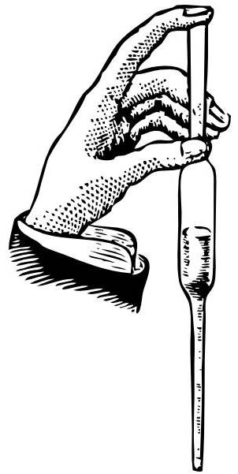Use a pipette or buretta to transfer a 20.0 mL aliquot of the sodium carbonate/ sodium chloride solution mixture into ONE of the conical flasks given.



2 **During the session your supervisor will come around and observe your technique in using the buretta. Please make sure you have been seen and ask if you have not!**

3

3 Titrate the 20.0 ml aliquot of sodium carbonate/sodium chloride solution mixture (conical flask) against the standardised hydrochloric acid solution from the burette by selecting **ONE** of the two indicators provided.



**Put up your hand** and ask your supervisor to assess the colour at the end point.

3

4 Repeat Steps 1 and 3 until you obtain consistent results.

Record all your results in the table below and calculate the average titration volume.

3

***Burette Reading***

|  |  |  |  |  |
| --- | --- | --- | --- | --- |
| **Titration** | **1** | **2** | **3** | **4** |
| Final Volume (V2) |  |  |  |  |
| Initial Volume (V1) |  |  |  |  |
| Titration Volume (mL)  (ΔV) = V2 - V1 |  |  |  |  |

2

Average Titration Volume = ________ mL

**5** Write a balanced **IONIC** chemical equation for the titration reaction between HCl and Na2CO3 in the

space provided below. Include in your equation the **correct states** of matter.

2

________________________________________________________________________________________

**Additional information from the whiteboard**

Concentration of standardised HCl = _____________ mol L-1

Mass of Na2CO3/NaCl mixture = _____________ g L-1

**6** Calculation:

Use your titration results **and** additional information from the whiteboard to calculate the percentage by mass of Na2CO3 in the Na2CO3/NaCl mixture.

% by mass of Na2CO3 = m (Na2CO3) / m (Na2CO3/NaCl) x 100

4

=

Final Answer

|  |  |  |  |  |  |
| --- | --- | --- | --- | --- | --- |
| |  |  |  |  |  | | --- | --- | --- | --- | --- | | Accuracy | 0 | 1 | 2 | 3 |   % by mass of Na2CO3 to **three (3)** significant figures = ____________**%** |

**Volumetric Analysis – Written Section (20 marks)**

Name: _____________________________________________________

Teacher: _____________________________________________________

In each of the following, write the correct name, formula, number or descriptive term that best match the description.

|  |  |  |
| --- | --- | --- |
| 1 | A name given to a solution of exactly known concentration that can be obtained highly pure with a known formula and high molecular mass. |  |
| 2 | ONE (1) example of a substance that satisfies the conditions listed in Question 1. |  |
| 3 | A name given to glass equipment used to accurately deliver a **fixed** volume of solution. |  |
| 4 | Name of glass equipment that must **not** be pre-rinsed with the solution to be added to it. |  |
| 5 | The level of accuracy to which final and initial volumes should be read from the burette. (Plus or minus ? mL) |  |
| 6 | A name given to the **volume difference** between the initial volume and the final volume of titration. |  |
| 7 | Name of a substance that can be added to the reaction mixture in the conical flask **without** affecting the outcome of the titration. |  |
| 8 | Give an example of a SYSTEMATIC error that could occur in this experiment. |  |
| 9 | Write the name of an indicator that would be suitable in the titration between ethanoic acid and sodium hydroxide. |  |
| 10 | Write the reading (to the correct number of decimal places)  shown on the burette opposite. |  |

The following questions refers to the following titration:

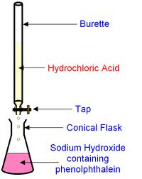

**Ethanoic acid**

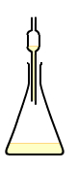

Pipette or

Buretta

For this experiment, state the correct **final** rinsing solution for each of the following glassware:

|  |  |  |
| --- | --- | --- |
| 11 | Burette |  |
| 12 | Pipette/Buretta |  |
| 13 | Conical flask |  |

Questions 15-18 refer to the use of indicators in the titration above.

|  |  |  |
| --- | --- | --- |
| 14 | State the **change** in the colourof **phenolphthalein** indicator as the titration proceeds. | From _____ to ______ |
| 15 | State the pH range of the reaction mixture at the **equivalence point**. |  |
| 16 | State the **change** in indicator colourif **methyl orange** was usedinstead of phenolphthalein. | From _____ to ______ |
| 17 | State the pH at the **end point** of **methyl orange** indicator. |  |

State the effect of the following acts on the **volume** of ethanoic acid used to achieve the equivalence point in the titration above. Write your answer as **more acid is used**, **less acid is used** or **no effect.**

|  |  |  |
| --- | --- | --- |
| 18 | Distilled water was used as the final rinse for the burette. |  |
| 19 | Sodium hydroxide was used as the final rinse for the conical flask. |  |
| 20 | Methyl orange was used as the indicator. |  |

